1st Floor
17 Baker Street
Rosebank
Johannesburg
South Africa
2196
Tel: +27 (0) 11 442 2434
Fax: +27 (0) 11 442 2454

ADC Heatsink Chassis Thermal Analysis 2

System:
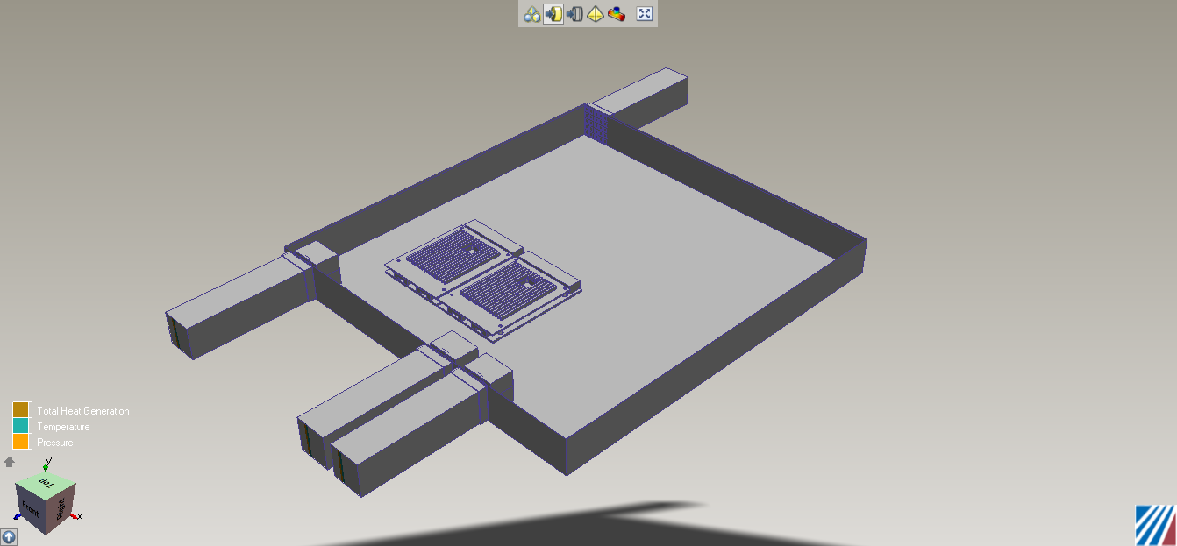
Volume: 450 x 431 x 44.45 mm Roach 2 Chassis
Inlet: 20 Degrees Celsius, 0 KPa Gauge.
3 Fans, 14.83 CFM (0,0,-1) direction

Scenario 1: ADC Heatsink as designed by Phil

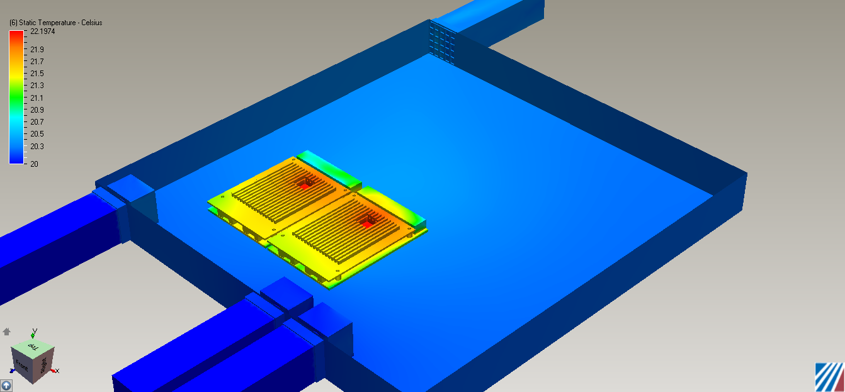
Component Thermal Summary:

ADC_PCB
Minimum Temperature = 20.731697/20.883699 Celsius
Maximum Temperature = 22.174850/22.197374 Celsius
Volume Averaged Temperature = 21.565813/21.566530 Celsius

ADC_CHIP
Minimum Temperature = 22.002235/21.983850 Celsius
Maximum Temperature = 22.174850/22.193455 Celsius
Volume Averaged Temperature = 22.129946/22.143957 Celsius

ADC_HEATSINK_SOLID
Minimum Temperature = 21.184099/21.326660 Celsius
Maximum Temperature = 22.167885/22.186201 Celsius
Volume Averaged Temperature = 21.635761/21.623938 Celsius

Volume
Minimum Temperature = 20.000000 Celsius
Maximum Temperature = 22.197374 Celsius
Volume Averaged Temperature = 20.322386 Celsius

Scenario 2: ADC with Solid Centre:
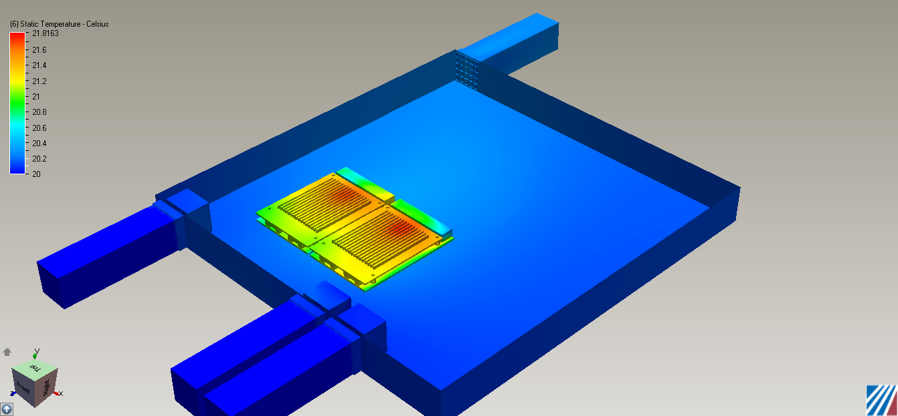
Component Thermal Summary:

ADC_PCB
Minimum Temperature = 20.501482/20.686430 Celsius
Maximum Temperature = 21.749989/21.816324 Celsius
Volume Averaged Temperature = 21.196833/21.273567 Celsius

ADC_CHIP
Minimum Temperature = 21.616917/21.667454 Celsius
Maximum Temperature = 21.749239/21.814713 Celsius
Volume Averaged Temperature = 21.711565/21.767021 Celsius

ADC_HEATSINK_SOLID
Minimum Temperature = 20.858450/20.992380 Celsius
Maximum Temperature = 21.736637/21.800669 Celsius
Volume Averaged Temperature = 21.301785/21.360006 Celsius

Name: Volume
Minimum Temperature = 20.000000 Celsius
Maximum Temperature = 21.816324 Celsius
Volume Averaged Temperature = 20.207525 Celsius

Scenario 3: No Heatsink

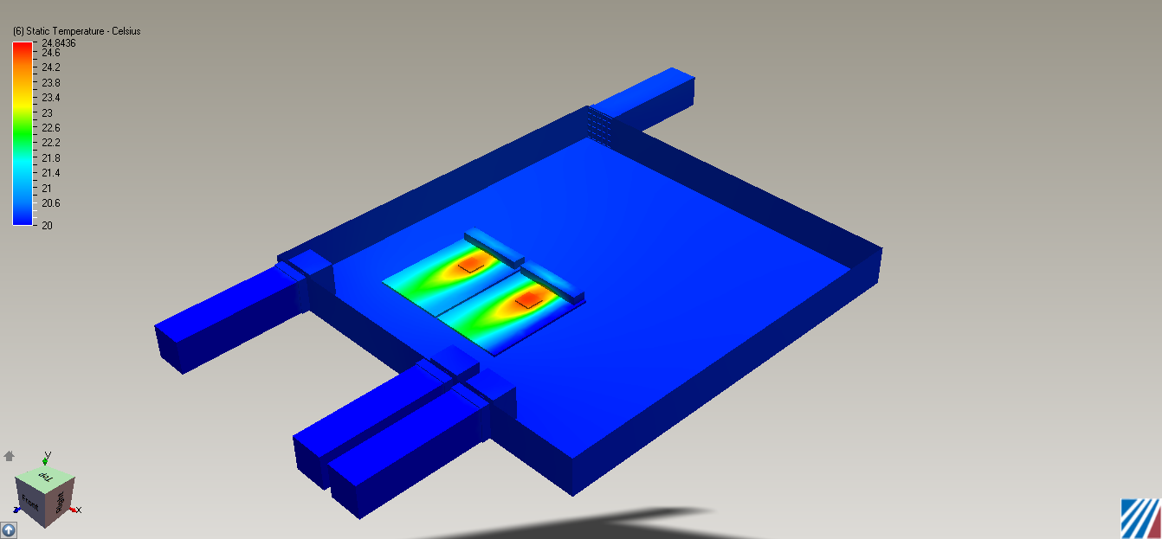
Component Thermal Summary:

ADC_PCB
Minimum Temperature = 20.316292/20.000000 Celsius
Maximum Temperature = 24.428749/24.583735 Celsius
Volume Averaged Temperature = 21.998354/21.961254 Celsius

ADC_CHIP
Minimum Temperature = 23.710598/23.987743 Celsius
Maximum Temperature = 24.433212/24.585785 Celsius
Volume Averaged Temperature = 24.280407/24.448376 Celsius

Volume
Minimum Temperature = 20.000000/ Celsius
Maximum Temperature = 24.843624 Celsius
Volume Averaged Temperature = 20.230171 Celsius

